**Spring REST Using Spring Boot**

**Create a Spring Web Project using Maven**   
   
Follow steps below to create a project:

1. Go to <https://start.spring.io/>
2. Change Group as “com.cognizant”
3. Change Artifact Id as “spring-learn”
4. Select Spring Boot DevTools and Spring Web
5. Create and download the project as zip
6. Extract the zip in root folder to Eclipse Workspace
7. Build the project using ‘mvn clean package -Dhttp.proxyHost=proxy.cognizant.com -Dhttp.proxyPort=6050 -Dhttps.proxyHost=proxy.cognizant.com -Dhttps.proxyPort=6050 -Dhttp.proxyUser=123456’ command in command line
8. Import the project in Eclipse "File > Import > Maven > Existing Maven Projects > Click Browse and select extracted folder > Finish"
9. Include logs to verify if main() method of SpringLearnApplication.
10. Run the SpringLearnApplication class.

SME to walk through the following aspects related to the project created:

1. src/main/java - Folder with application code
2. src/main/resources - Folder for application configuration
3. src/test/java - Folder with code for testing the application
4. SpringLearnApplication.java - Walkthrough the main() method.
5. Purpose of @SpringBootApplication annotation
6. pom.xml
   1. Walkthrough all the configuration defined in XML file
   2. Open 'Dependency Hierarchy' and show the dependency tree.

**Output:**

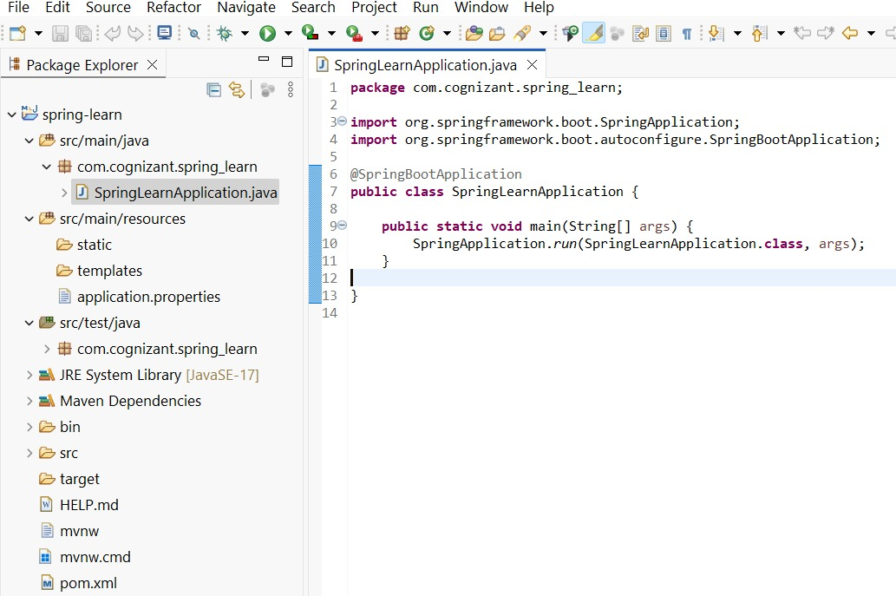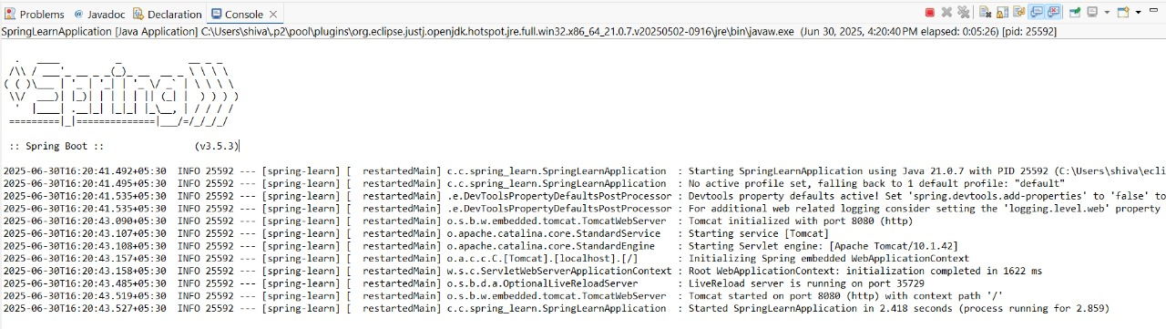

**Spring Core – Load SimpleDateFormat from Spring Configuration XML**   
   
SimpleDateFormat with the pattern ‘dd/MM/yyyy’ is created in multiple places of an application. To avoid creation of SimpleDateFormat in multiple places, define a bean in Spring XML Configuration file and retrieve the date.  
   
Follow steps below to implement:

* Create spring configuration file date-format.xml in src/main/resources folder of 'spring-learn' project
* Open <https://docs.spring.io/spring-framework/docs/current/spring-framework-reference/core.html#beans-factory-metadata>
* Copy the XML defined in the section of previous step URL and paste it into date-format.xml
* Define bean tag in the XML with for date format.
* Create new method displayDate() in SpringLearnApplication.java
* In displayDate() method create the ApplicationContext.
* Get the dateFormat using getBean() method.
* Using the format variable try to parse string '31/12/2018' to Date class and display the result using System.out.println.
* Run the application as 'Java Application' and check the result in console log output.

**Output:**

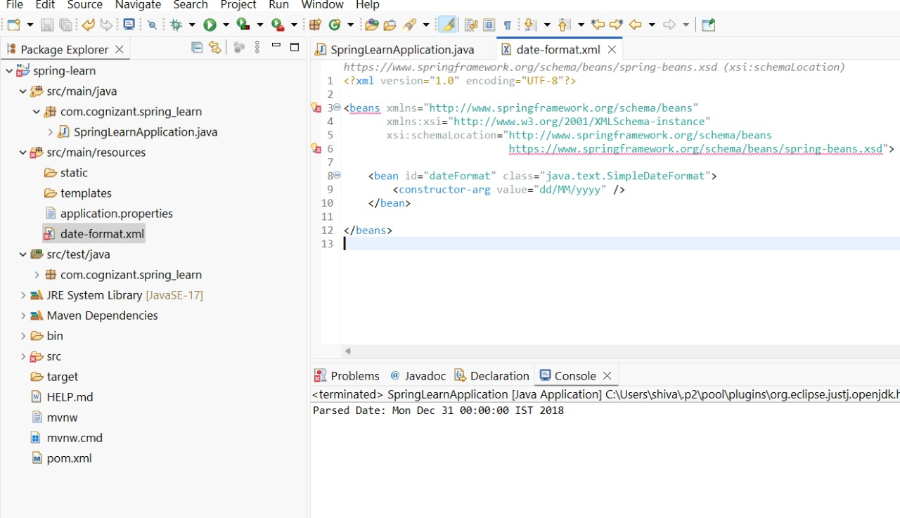

**Spring Core - Incorporate Logging**   
   
Incorporate logging in the Spring Boot project created in previous hands on. Refer steps below:

* Create application.properties if not yet created in src/main/resources folder
* Add below lines in application.properties
* In SpringLearnApplication.java include the following imports:
* Include the below static variable in SpringLearnApplication.java:
* Include info log on start and end of method. Debug log for displaying the date (refer code below)

**Output:**

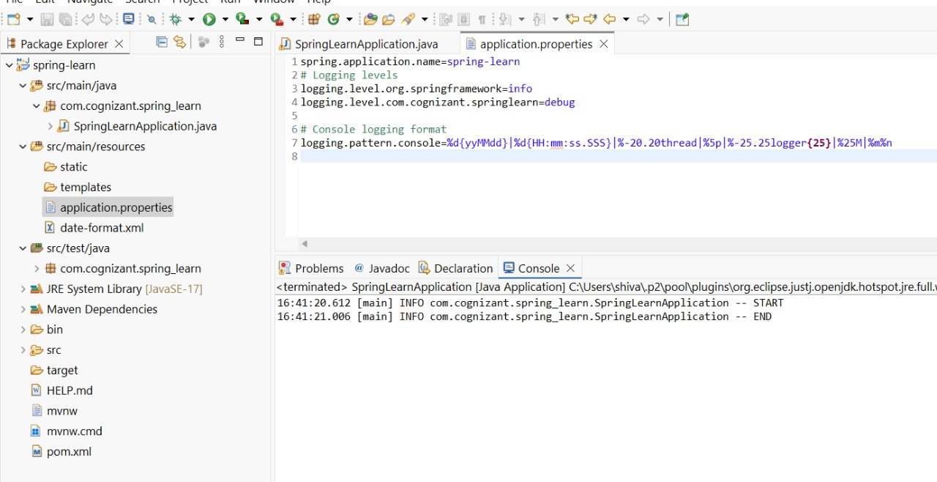

**Spring Core – Load Country from Spring Configuration XML**   
   
An airlines website is going to support booking on four countries. There will be a drop down on the home page of this website to select the respective country. It is also important to store the two-character ISO code of each country.

|  |  |
| --- | --- |
| **Code** | **Name** |
| US | United States |
| DE | Germany |
| IN | India |
| JP | Japan |

Above data has to be stored in spring configuration file. Write a program to read this configuration file and display the details.  
   
Steps to implement

* Pick any one of your choice country to configure in Spring XML configuration named country.xml.
* Create a bean tag in spring configuration for country and set the property and values.
* Create Country class with following aspects:
  + Instance variables for code and name
  + Implement empty parameter constructor with inclusion of debug log within the constructor with log message as “Inside Country Constructor.”
  + Generate getters and setters with inclusion of debug with relevant message within each setter and getter method.
  + Generate toString() method
* Create a method displayCountry() in SpringLearnApplication.java, which will read the country bean from spring configuration file and display the country details. ClassPathXmlApplicationContext, ApplicationContext and context.getBean(“beanId”, Country.class). Refer sample code for displayCountry() method below.
* Invoke displayCountry() method in main() method of SpringLearnApplication.java.
* Execute main() method and check the logs to find out which constructors and methods were invoked.

SME to provide more detailing about the following aspects:

* bean tag, id attribute, class attribute, property tag, name attribute, value attribute
* ApplicationContext, ClassPathXmlApplicationContext
* What exactly happens when context.getBean() is invoked

**Output:**

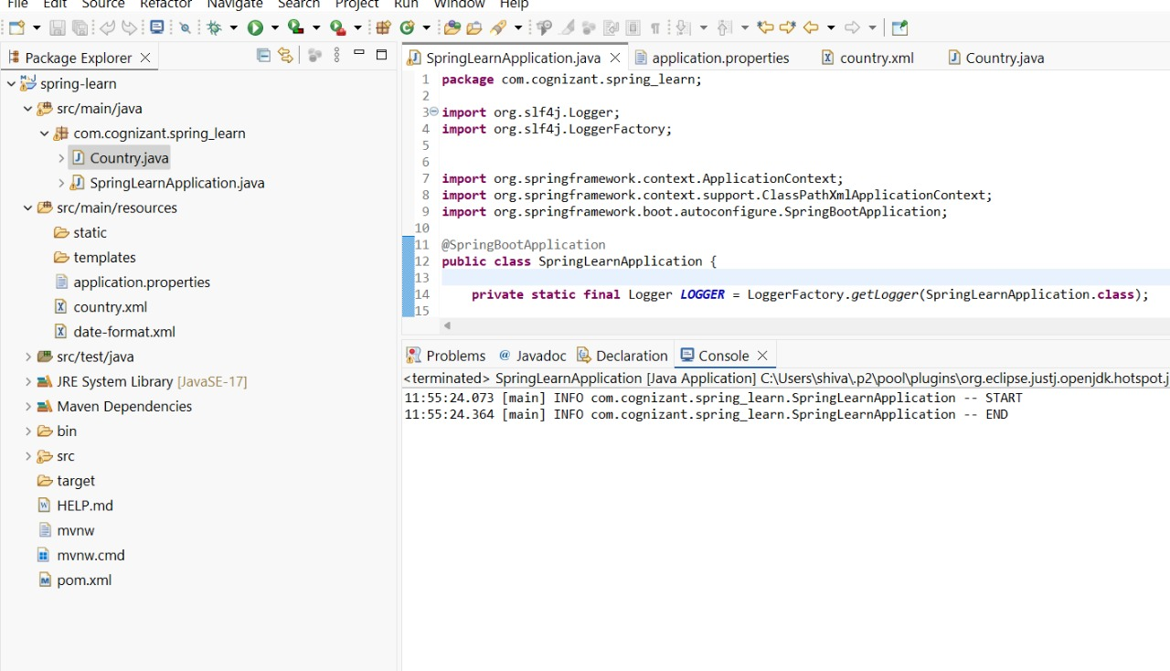

**Spring Core – Demonstration of Singleton Scope and Prototype Scope**   
   
The Country bean done in the previous hands on will be used to demonstrate the scopes in Spring. Implement the steps below.  
   
**Follow steps below to demonstrate Singleton Scope**

* Include a line in displayCountry() to get country bean reference one more time from the same application context. Only the third line of the below code snippet should be copied and pasted.
* The constructor will be called only once, which means that only one instance of Country bean is created

**Example Using Singleton**

**Output:**

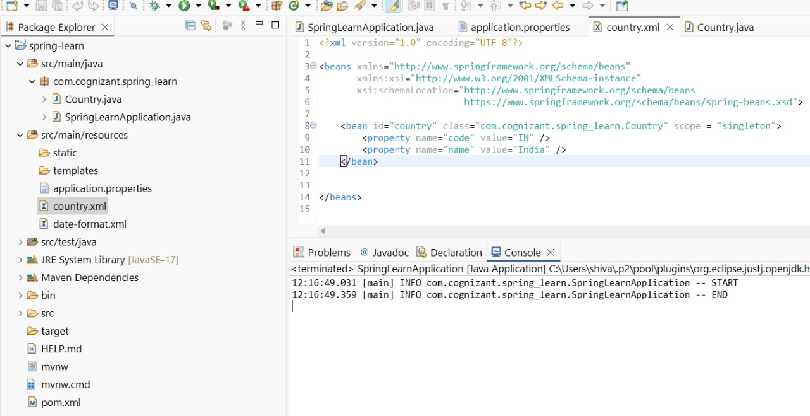

**Follow steps below to demonstrate Prototype Scope**

* Include scope="prototype" attribute in bean definition xml.
* Run the application
* Constructor will be called twice, which means that two instances of country is created.

**Example Using Prototype Scope**

**Output:**

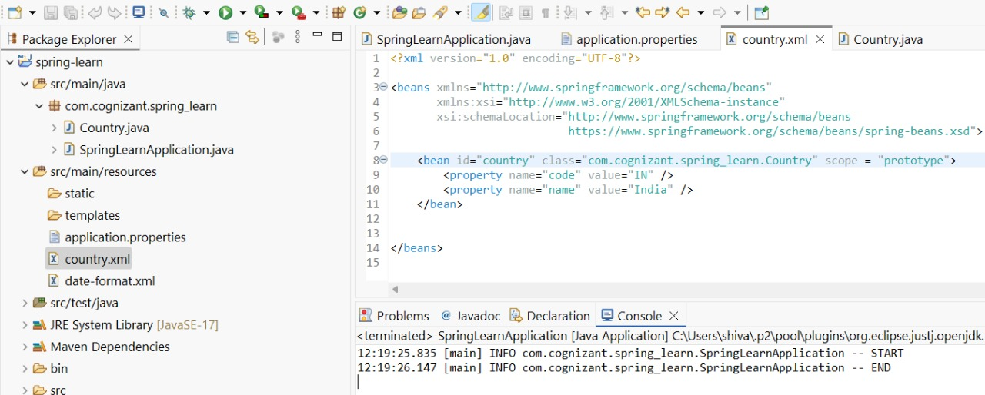

**Spring Core – Load list of countries from Spring Configuration XML**   
   
Our main objective was to retrieve the list of four countries for the airlines website. Refer steps below to get this incorporated.

* Create a separate bean for each of the four country in country.xml.
* Create an ArrayList of Country in country.xml. Refer code below.
* Include new method displayCountries() in SpringLearnApplication.java
* In displayCountries() read the country list created above
* Display the list of countries as debug log.

SME to provide detailing on below aspects:

* <list>
* <ref>
* bean attribute

**Output:**

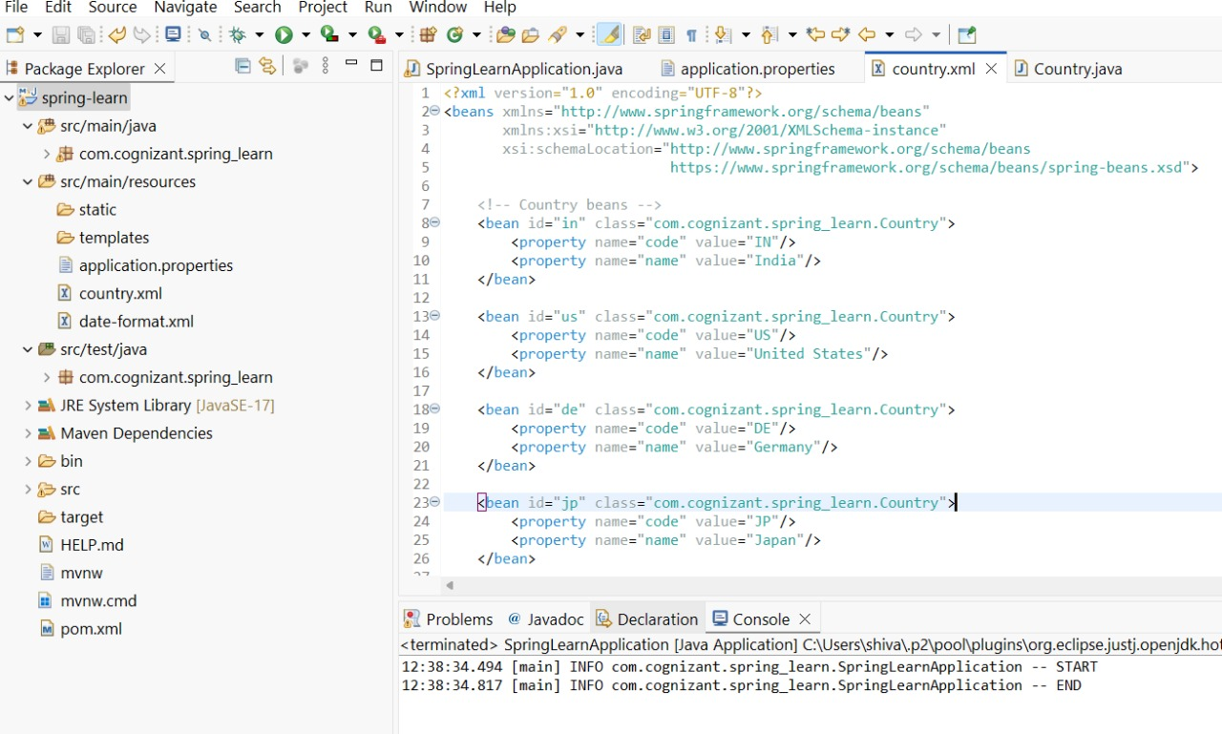

**Hello World RESTful Web Service**   
   
Write a REST service in the spring learn application created earlier, that returns the text "Hello World!!" using Spring Web Framework. Refer details below:  
   
**Method:** GET  
**URL:** /hello  
**Controller:** com.cognizant.spring-learn.controller.HelloController  
**Method Signature:** public String sayHello()  
**Method Implementation:** return hard coded string "Hello World!!"  
**Sample Request**: http://localhost:8083/hello  
**Sample Response:** Hello World!!

* Try the URL <http://localhost:8083/hello> in both chrome browser and postman.

**Output:**

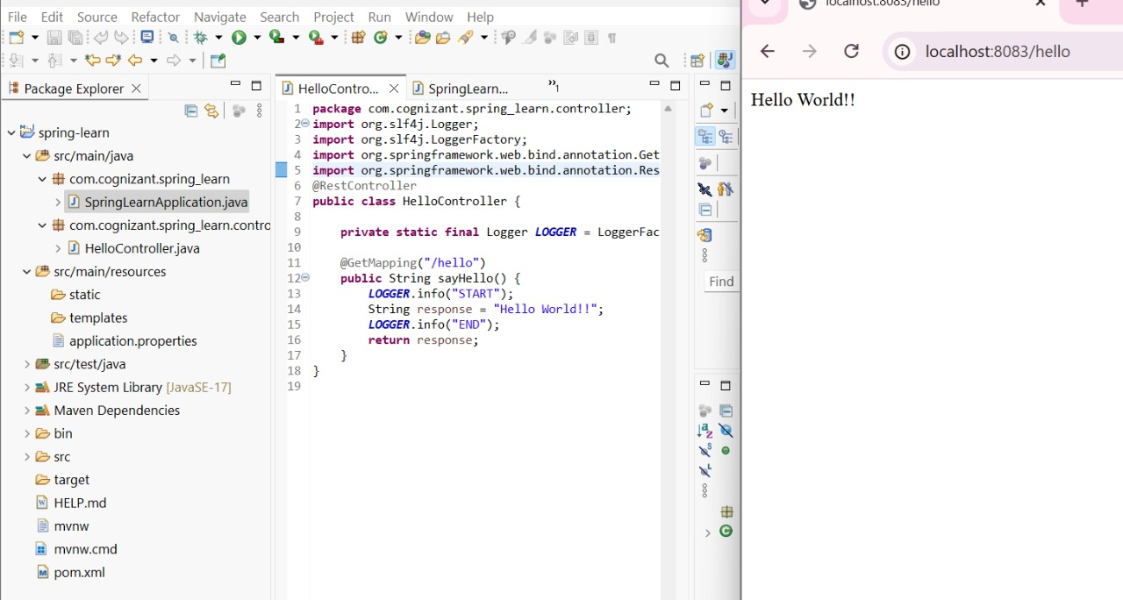

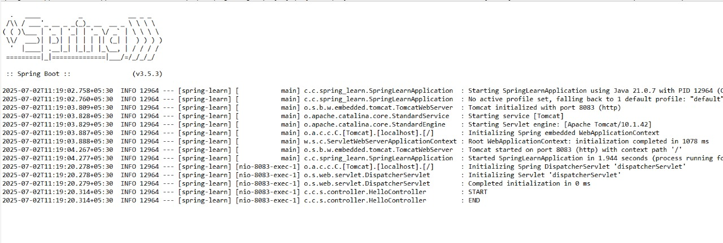

**REST - Country Web Service**   
   
Write a REST service that returns India country details in the earlier created spring learn application.  
   
**URL**: /country  
**Controller**: com.cognizant.spring-learn.controller.CountryController  
**Method Annotation**: @RequestMapping  
**Method Name**: getCountryIndia()  
**Method Implementation**: Load India bean from spring xml configuration and return  
**Sample Request**: <http://localhost:8083/country>**Sample Response**:

{

"code": "IN",

"name": "India"

}

SME to explain the following aspects:

* What happens in the controller method?
* How the bean is converted into JSON reponse?
* In network tab of developer tools show the HTTP header details received
* In postman click on "Headers" tab to view the HTTP header details received

**Output:**

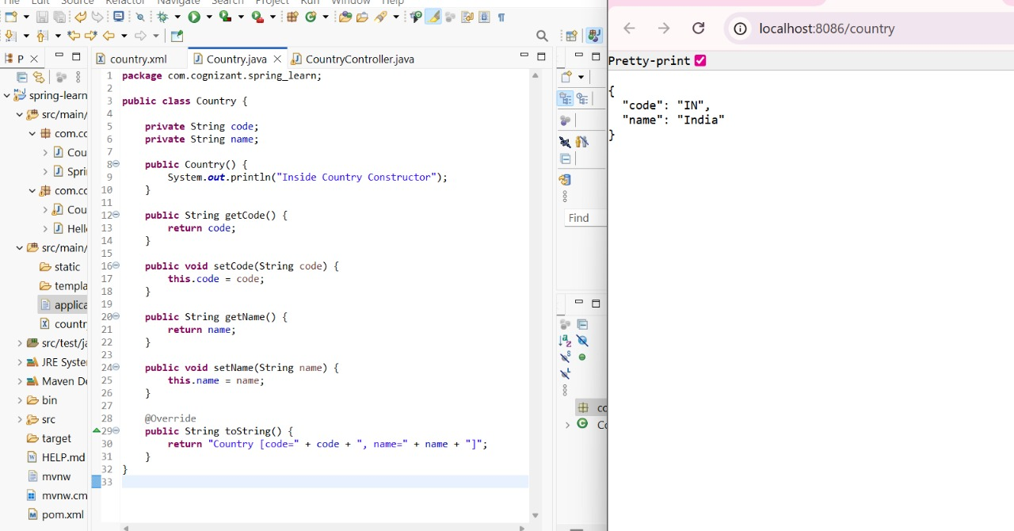

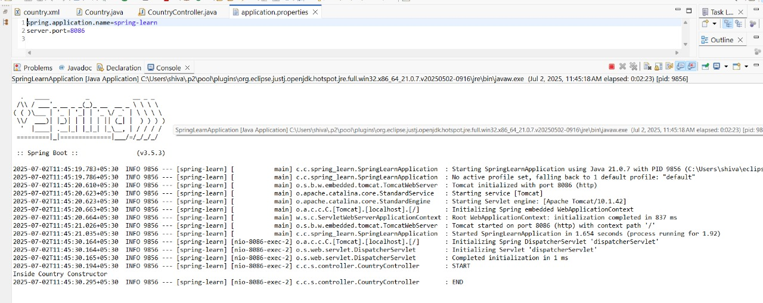

**REST - Get all countries**   
   
Write a REST service that returns all the countries.  
   
**Controller**: com.cognizant.spring-learn.controller.CountryController  
**Method Annotation**: @GetMapping("/countries")  
**Method Name**: getAllCountries()  
**Method Implementation**: Load country list from country.xml and return  
**Sample Request**: <http://localhost:8083/countries>**Sample Response**:

[

{ "code": "IN", "name": "India"},

{ "code": "US", "name": "United States"},

{ "code": "JP", "name": "Japan"},

{ "code": "DE", "name": "Germany"}

]

**Output:**

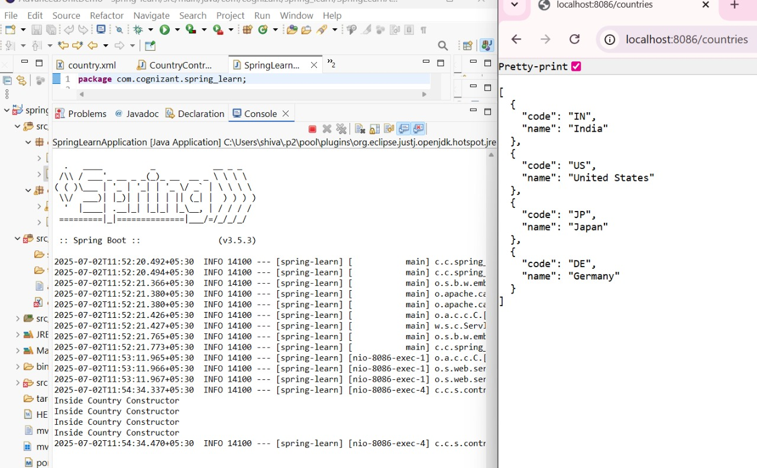

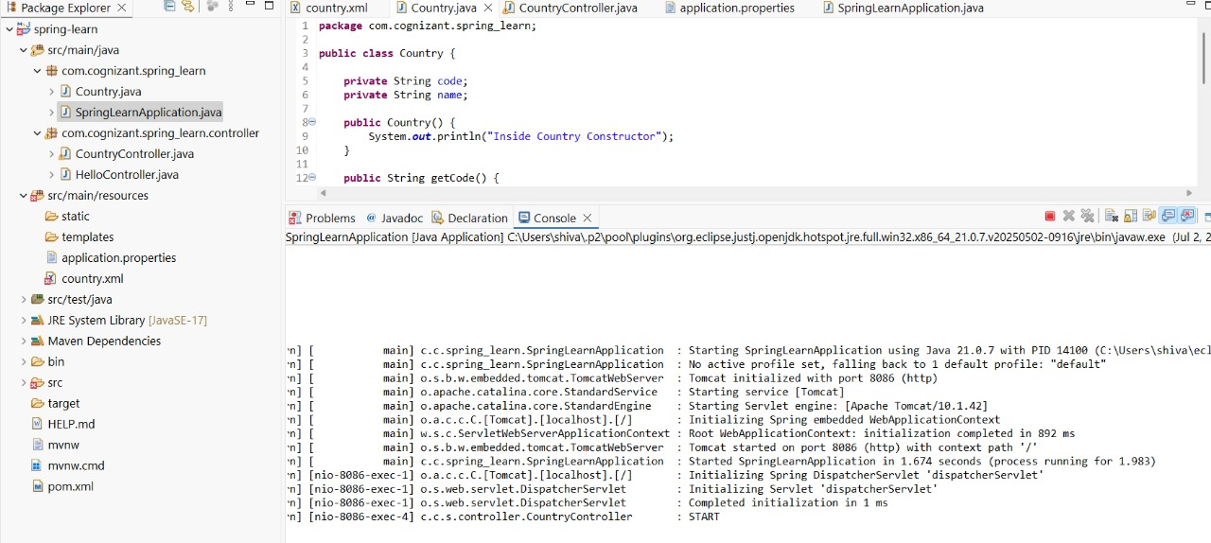

**REST - Get country based on country code**   
   
Write a REST service that returns a specific country based on country code. The country code should be case insensitive.  
   
**Controller**: com.cognizant.spring-learn.controller.CountryController  
 **Method Annotation:** @GetMapping("/countries/{code}")  
 **Method Name**: getCountry(String code)  
 **Method Implemetation**: Invoke countryService.getCountry(code)   
 **Service Method:** com.cognizant.spring-learn.service.CountryService.getCountry(String code)  
   
**Service Method Implementation**:

* Get the country code using @PathVariable
* Get country list from country.xml
* Iterate through the country list
* Make a case insensitive matching of country code and return the country.
* Lambda expression can also be used instead of iterating the country list

**Sample Request**: <http://localhost:8083/country/in>   
**Sample Response**:

{

"code": "IN",

"name": "India"

}

**Output:**

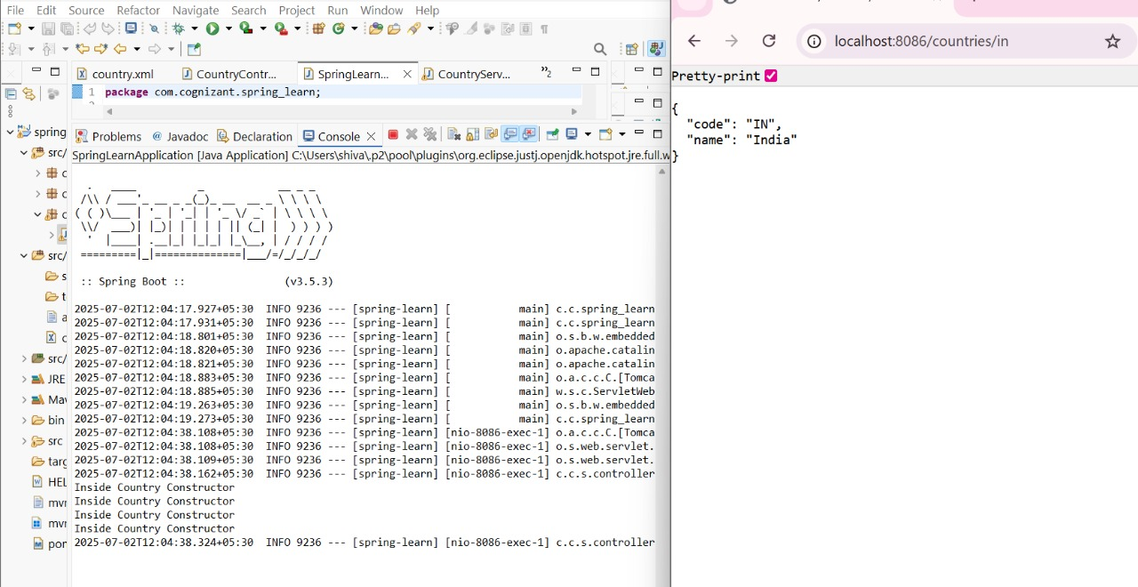

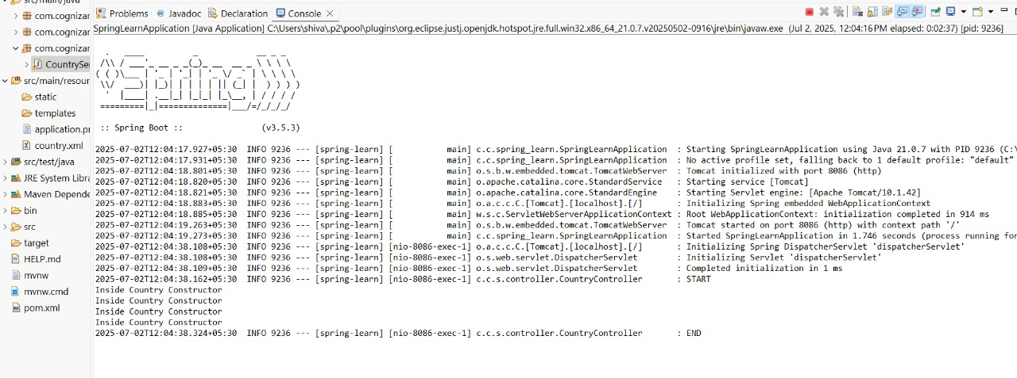

**REST - Get country exceptional scenario**   
   
In the previous hands on where we implemented getting country based on country code, what happens if the country code provided in the URL is not present.  
   
**Refer steps below to implement**

* Create a new exception class com.cognizant.springlearn.service.exception.CountryNotFoundException
* Include below specified annotation at the class level in CountryNotFoundException class

@ResponseStatus(value = HttpStatus.NOT_FOUND, reason = "Country not found")

* In CountryService.getCountry() method include the logic to throw CountryNotFoundException if the country code does not exists in the list.
* In CountryController.getCountry() method include throws clause in method signature. This will respond to the caller of the web service with appropriate error message in JSON format.
* Test the service in postman and using curl command. Refer below for executing curl command.

**Steps to invoke RESTful Web Service using curl command**

* Open Git Bash
* Execute the below command

curl -i <http://localhost:8090/country/az>

**Sample Request**: <http://localhost:8083/country/az>   
**Sample Response**:

{

"timestamp": "2019-10-02T03:27:54.521+0000",

"status": 404,

"error": "Not Found",

"message": "Country not found",

"path": "/country/az"

}

**Output:**

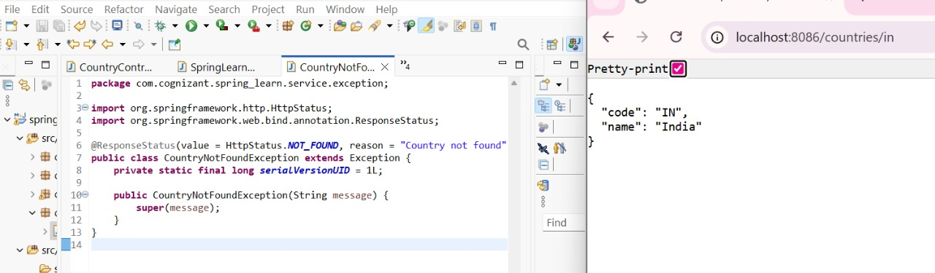

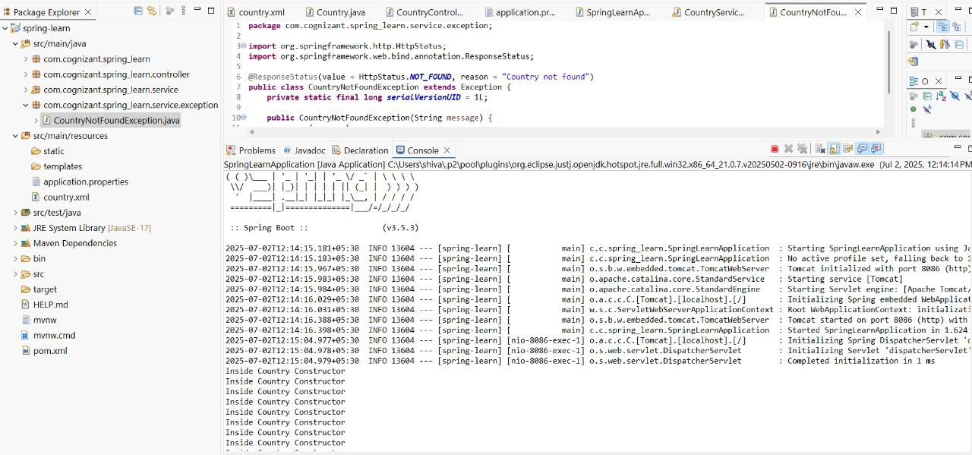

**MockMVC - Test get country service**   
   
Using MockMVC test the get country service.  
   
Create a test cases to test the following aspects:

* Test is the CountryController is loaded
* Invoke the service to get country and check in the response if it contains code as "IN" and name as "India"

**Output:**

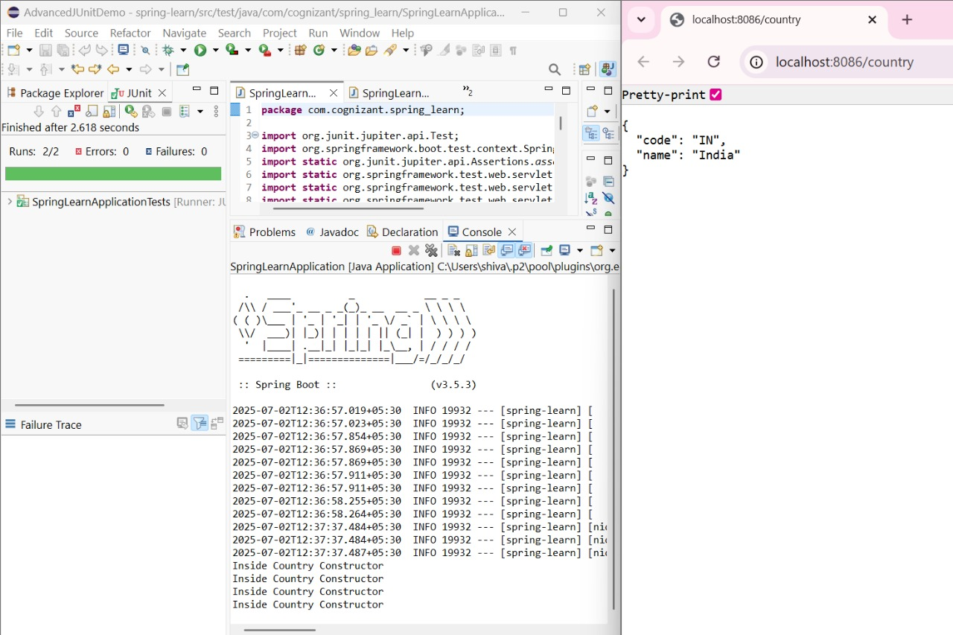

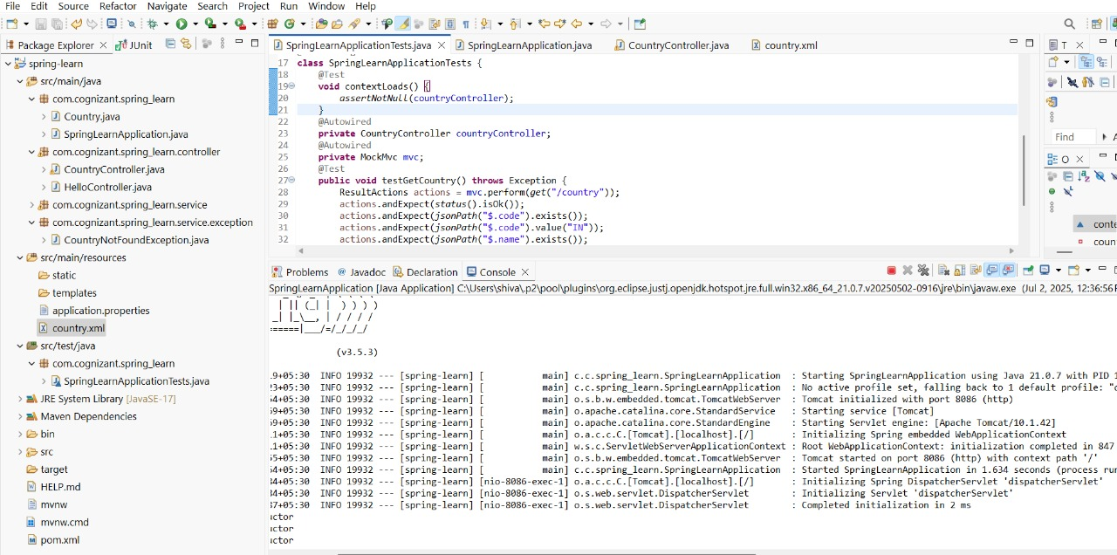

**Create RESTful Web Service to handle POST request of Country**

**A new RESTful Web Service method to handle POST request of Country. Follow steps below to incorporate the same:**

Create new method in CountryController based on the following details:

Annotation - @PostMapping()

Method Signature - public void addCountry()

Within this method  include "Start" logger.

Start the web application

**Open Git Bash**

Execute the following curl command, to invoke the web service:

-i to display the

**Output:**

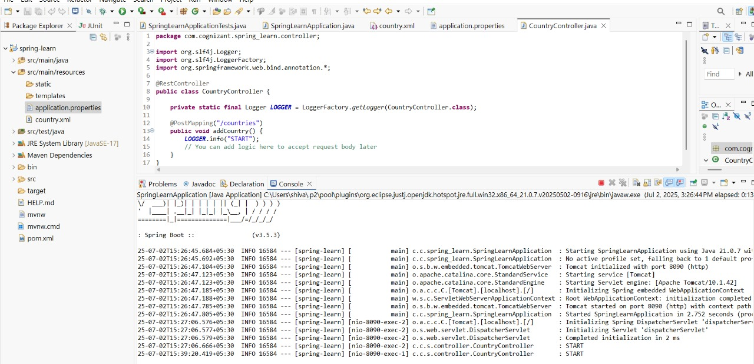

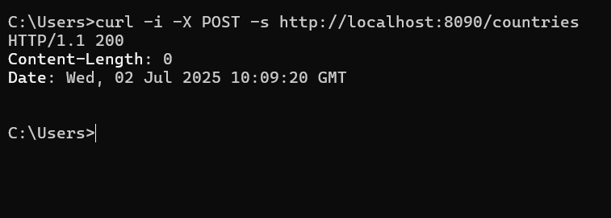

**Read country data as a bean in RESTful Web Service**

**The country data should be included in the request payload, which should be read by the controller method.**

Follow steps below to incorporate the same:

Include country as parameter to addCountry() method with @RequestBody annotation and country as parameter. Refer method signature below.

public Country addCountry(@RequestBody Country country)

Include log to display country details

Return the country. This is to check if country details are populated correctly

Invoke the service using the following curl command. This can also be tried for execution from Postman.

-H denotes inclusion of header. This denotes that we are sending content type in the request header and it mentions that the request payload is of type JSON

-d denotes the data payload sent in the request. This represents the country to be added

curl -i -H 'Content-Type: application/json' -X POST -s -d '{"code":"IN","name":"India"}' http://localhost:8090/countries

**Output:**

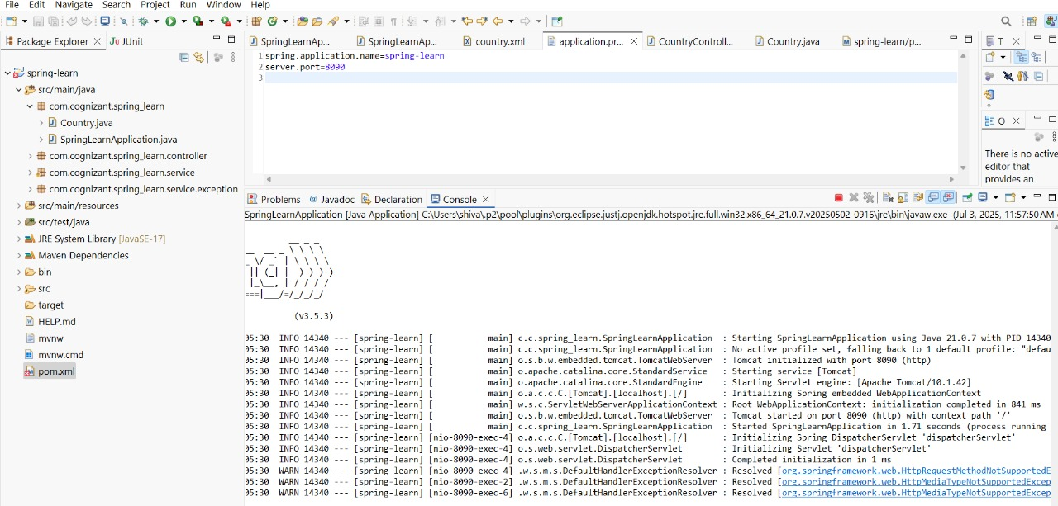

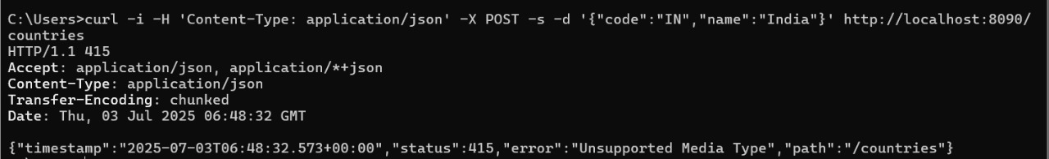

**Validating country code**   
  
As the POST request is a plain text, there are good possibilities to key in incorrect data. Moreover, hackers might try to pass inconsistent data which might affect the integrity of the application. Hence it becomes important that necessary check are in place for all the fields. In this hands on we will take a simple validation criteria and will see how it can be implemented.  
  
The country code needs to be validated and ensured that it does not exceed more than 2 characters. Refer the steps below to incorporate the same: 

* Open Country.java and include below annotations for the code property. @NotNull ensure that code is not null. @Size ensure that the width is exactly 2 characters.

    @NotNull

    @Size(min=2, max=2, message="Country code should be 2 characters")

    private String code;

* In CountryController.addCountry() method add below lines after the logger. This uses the javax.validation specification to check if the bean has errors based on the annotations defined in the earlier step. All new class references in this code snippet needs to be imported from javax.validation.

// Create validator factory

       ValidatorFactory factory = Validation.buildDefaultValidatorFactory();

        Validator validator = factory.getValidator();

  // Validation is done against the annotations defined in country bean

        Set<ConstraintViolation<Country>> violations = validator.validate(country);

        List<String> errors = new ArrayList<String>();

  // Accumulate all errors in an ArrayList of type String

        for (ConstraintViolation<Country> violation : violations) {

            errors.add(violation.getMessage());

        }

  // Throw exception so that the user of this web service receives appropriate error message

        if (violations.size() > 0) {

            throw new ResponseStatusException(HttpStatus.BAD_REQUEST, errors.toString());

        }

* Invoke the service using curl and check the response. Refer sample response below:

HTTP/1.1 400

Content-Type: application/json;charset=UTF-8

Transfer-Encoding: chunked

Date: Wed, 02 Oct 2019 10:28:56 GMT

Connection: close

{"timestamp":"2019-10-02T10:28:56.506+0000","status":400,"error":"Bad Request","message":"[Country code should be 2 characters]","path":"/countries"}

**Output:**

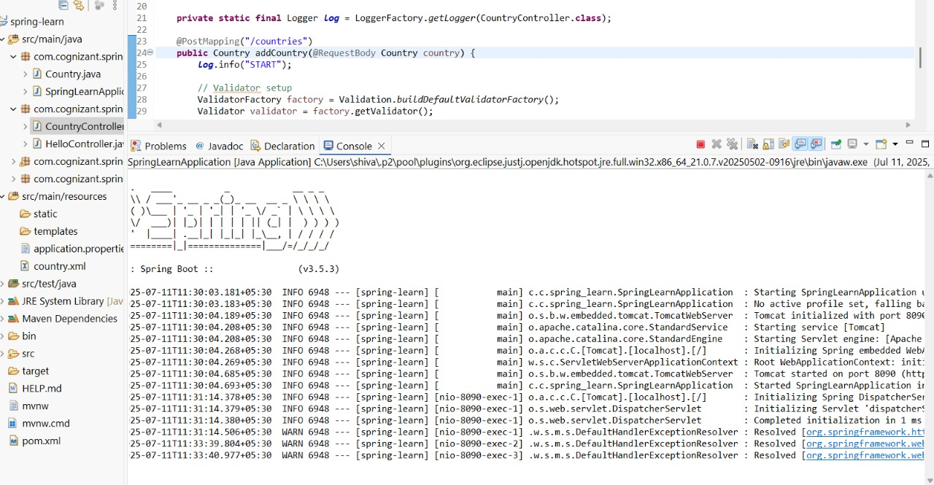

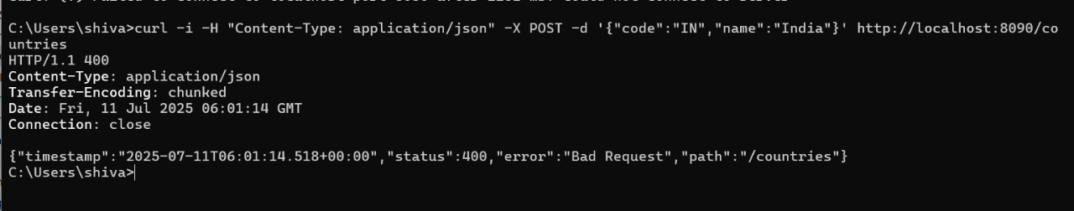

**Include global exception handler for validation errors**   
  
Following steps create a global validation error handler. This will validate all errors that may happen in any controller.  
  
**Create global exception handler** 

* Create class com.cognizant.springlearn.GlobalExceptionHandler that extends ResponseEntityExceptionHandler with annotation @ControllerAdvice
* Include method handler for handling the validation error and include a start logger within the method implementation.

    @Override

    protected ResponseEntity<Object> handleMethodArgumentNotValid(MethodArgumentNotValidException ex,

            HttpHeaders headers, HttpStatus status, WebRequest request) {

        LOGGER.("Start");

    }

* Refer imports below:

import org.springframework.http.HttpHeaders;

import org.springframework.http.HttpStatus;

import org.springframework.http.ResponseEntity;

import org.springframework.web.bind.MethodArgumentNotValidException;

import org.springframework.web.bind.annotation.ControllerAdvice;

import org.springframework.web.context.request.WebRequest;

import org.springframework.web.servlet.mvc.method.annotation.ResponseEntityExceptionHandler;

* Include @Valid annotation in the addCountry() method. This initimates spring framework to validate the country bean based on the validation annotations added in the Country class. Refer code below:

public Country addCountry(@RequestBody @Valid Country country)

* Remove all the validation code included in the previous hands on.
* Run the application and invoke the curl request with single character for country code.

curl -i -H 'Content-Type: application/json' -X POST -s -d '{"code":"I","name":"India"}' <http://localhost:8090/countries>

* Check the logs and see if the start logger is present. Also notice that the logs of CountryController is not present, which means that the global exception handler method is called if there are validation errors and the controller method is not invoked.

**Response with bad request in global exception handler** 

* Include the below code in the handleMethodArgumentNotValid() method:

        // Map that contains the error details

        Map<String, Object> body = new LinkedHashMap<>();

        body.put("timestamp", new Date());

        body.put("status", status.value());

        // Get all validation errors

        List<String> errors = ex.getBindingResult().getFieldErrors().stream().map(x -> x.getDefaultMessage())

                .collect(Collectors.toList());

// Add errors to the response map

        body.put("errors", errors);

  LOGGER.info("End");

        return new ResponseEntity<>(body, headers, status);

* Execute the updated web application and execute the curl command with single character for country code
* See expected response below.

HTTP/1.1 400

Content-Type: application/json;charset=UTF-8

Transfer-Encoding: chunked

Date: Thu, 03 Oct 2019 04:10:17 GMT

Connection: close

{"timestamp":"2019-10-03T04:10:17.277+0000","status":400,"errors":["Country code should be 2 characters"]}

**Output:**

